**MAIN PROJECT 3**

**Launching an EC2 instance with Lambda**

Steps:

1. Creating a IAM policy also edit the json code :-

As a prerequisite for creating Lambda function, we need to create a user role with a custom policy.

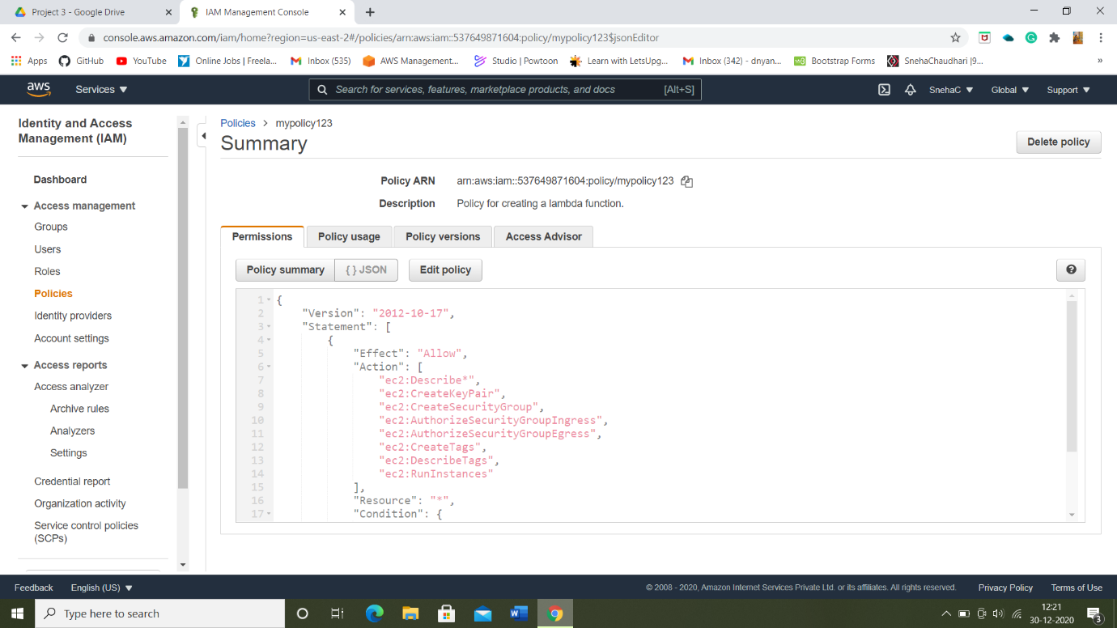

2) Checking the policy we created exists in the policy list (by filtering a policy):

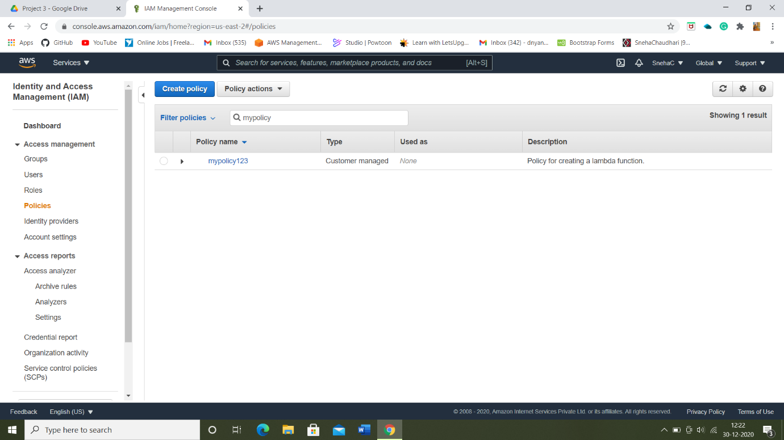

3) Creating a role by attaching a policy we created:

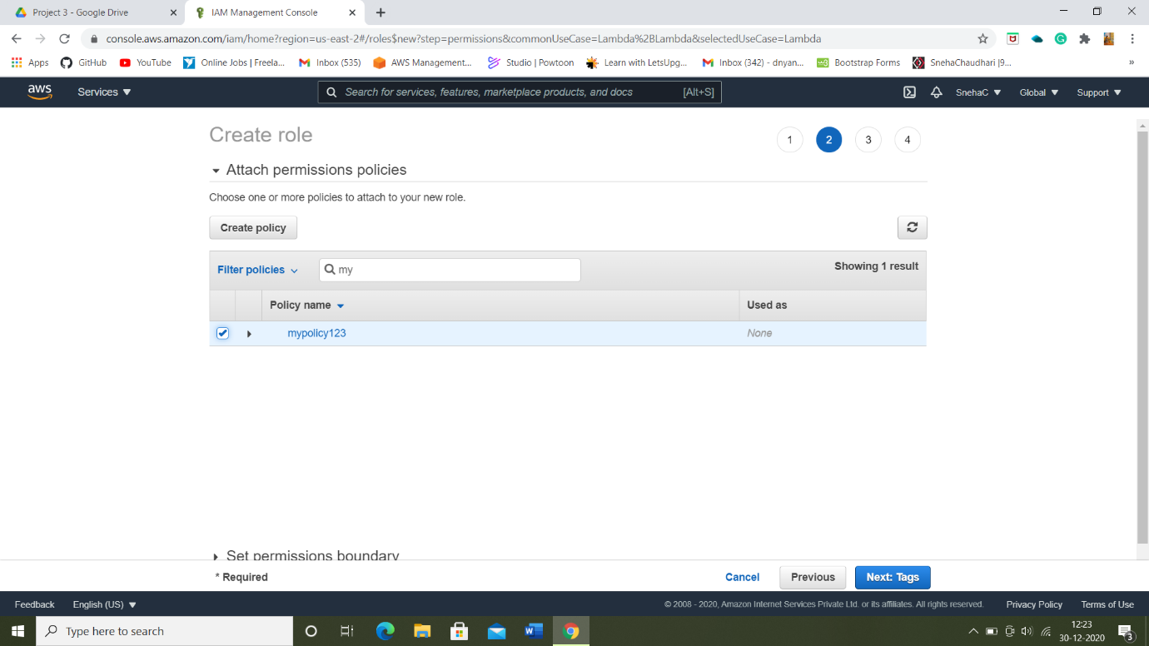

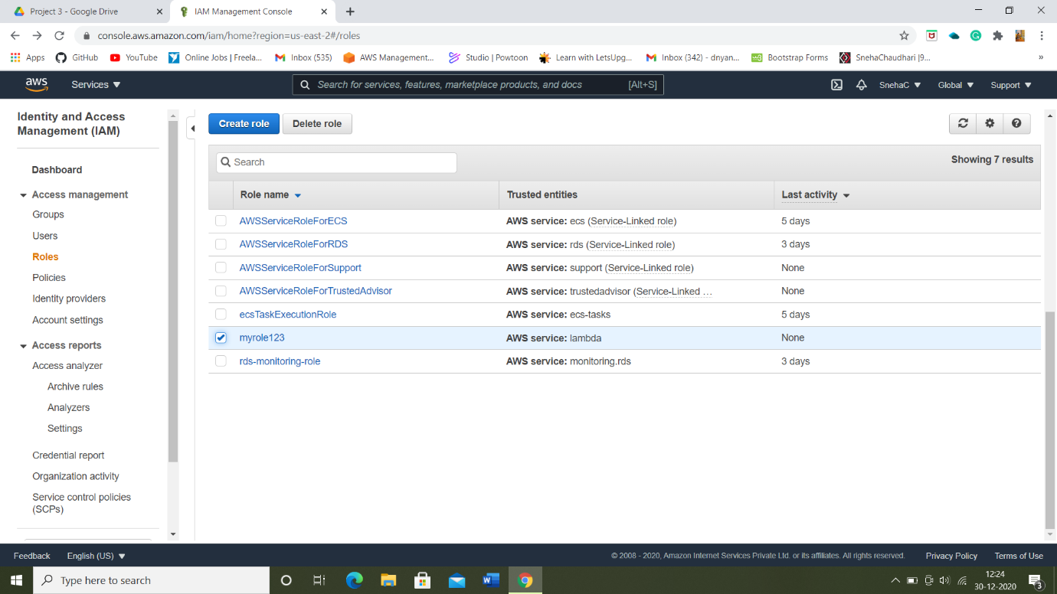

4) Creating a lambda function using existing role and a python language also writing a required function code:

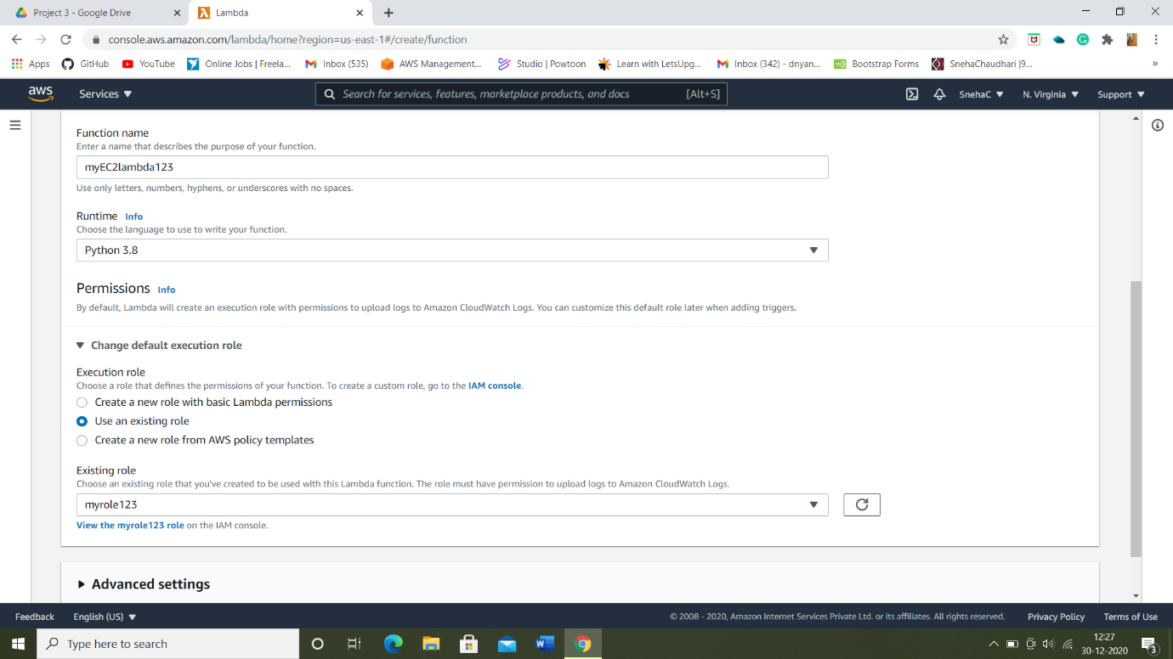

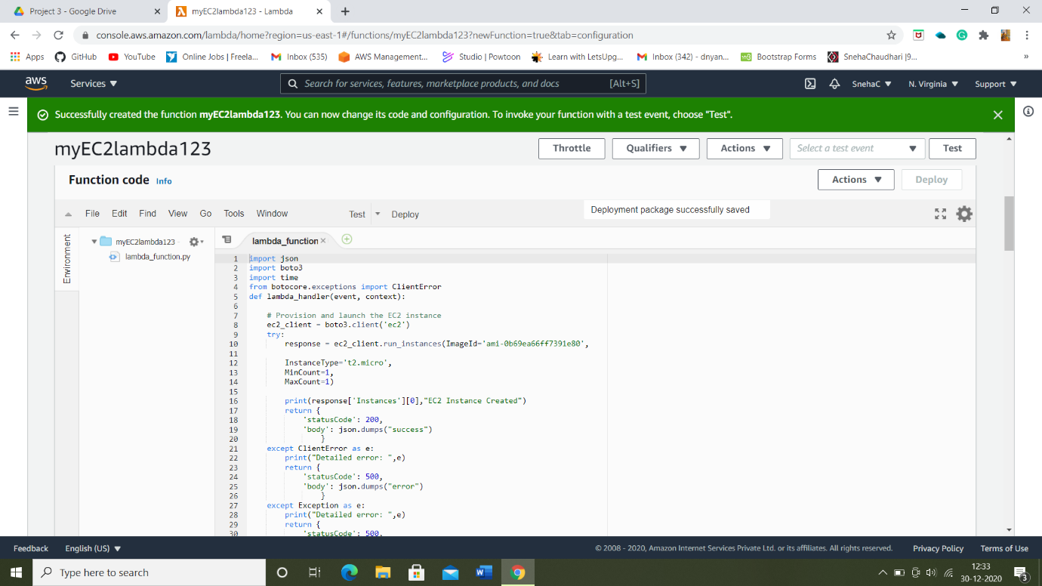

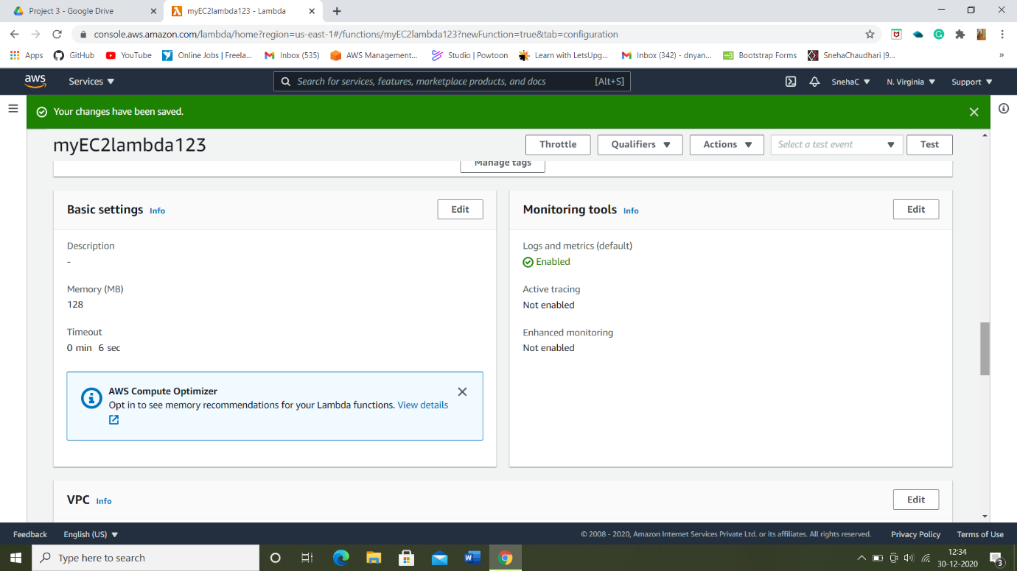

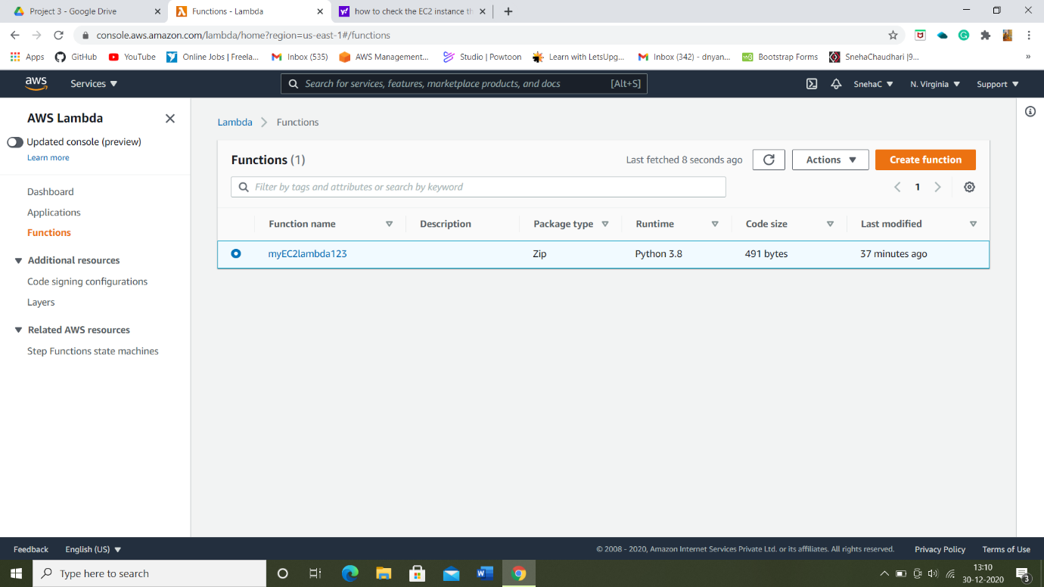

5) Configuring Test page using ec2, once the function code is configured execution successful result pops-up :-

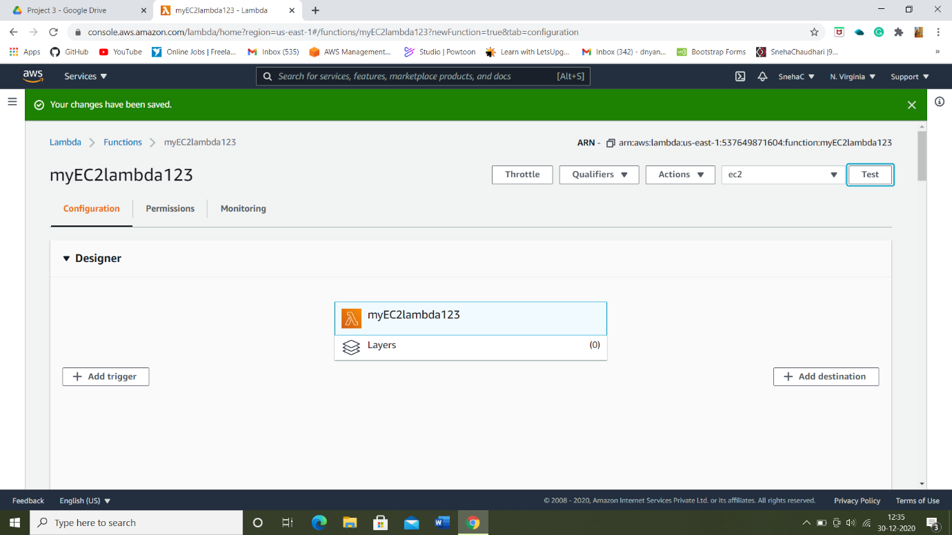

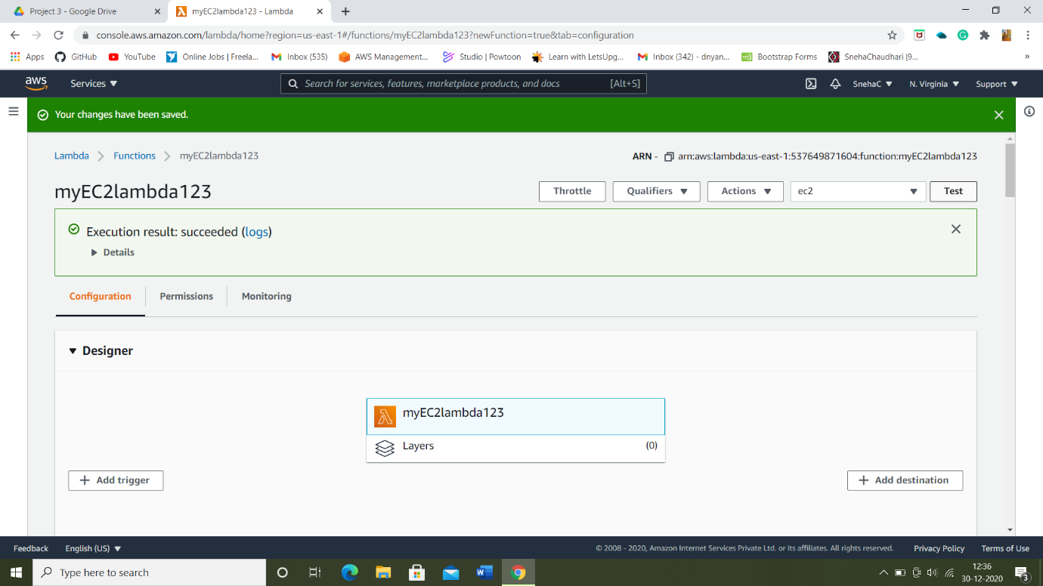

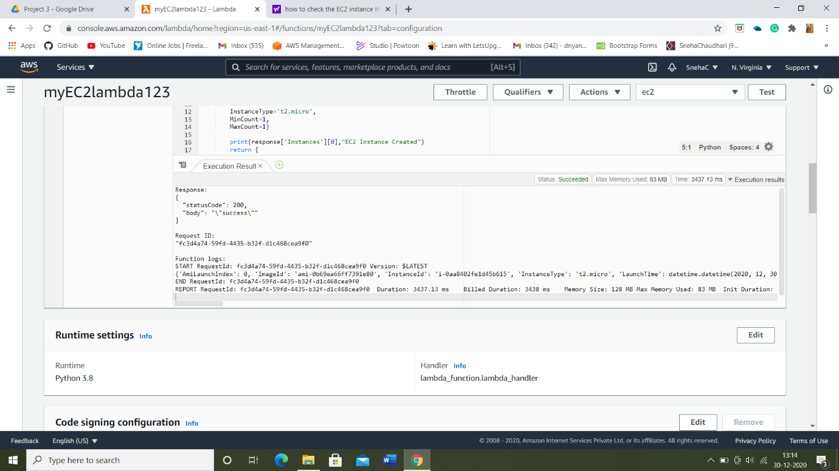

6) Checking the Log Output: Details of the EC2 instance provisioned.

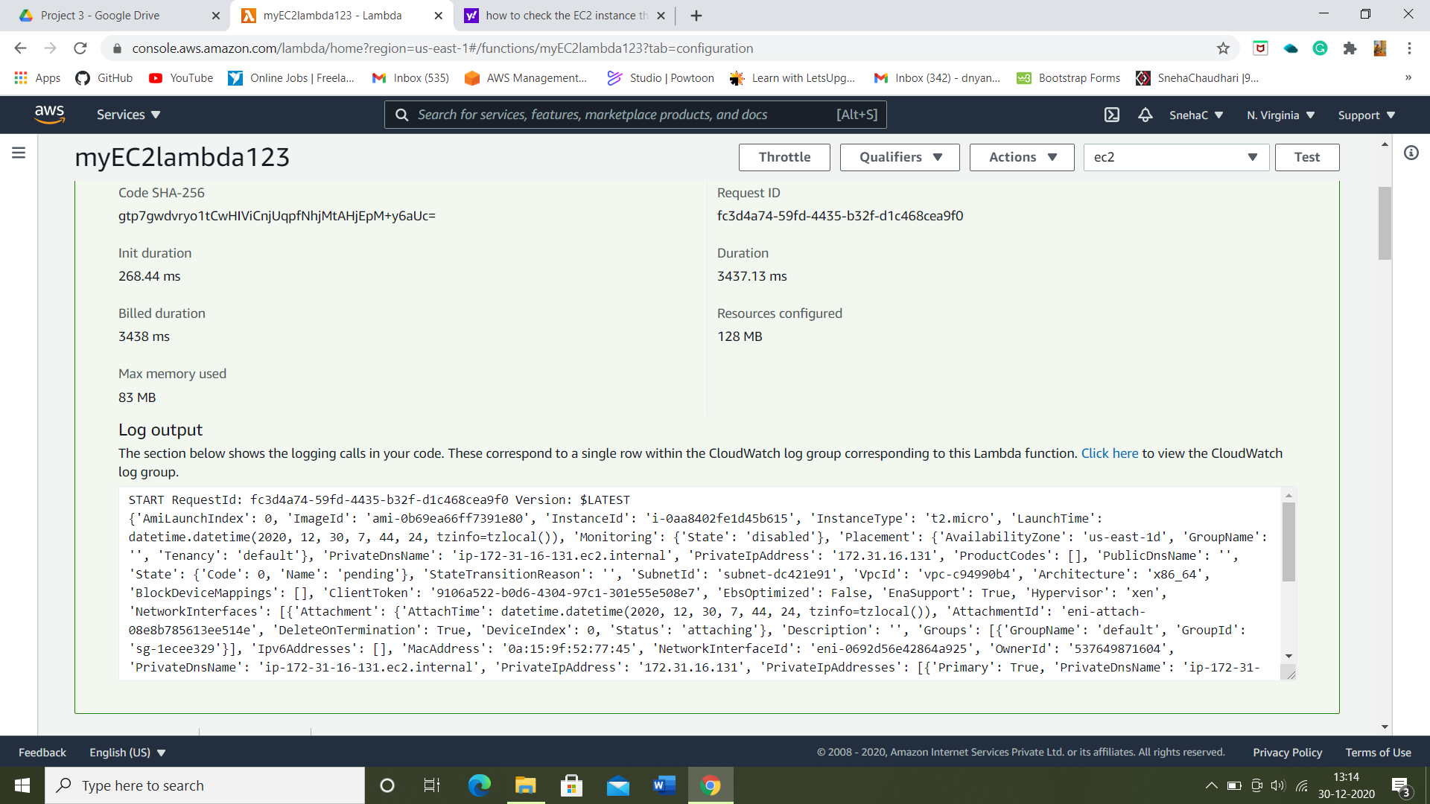

6) Checking that the EC2 instance launched successfully.

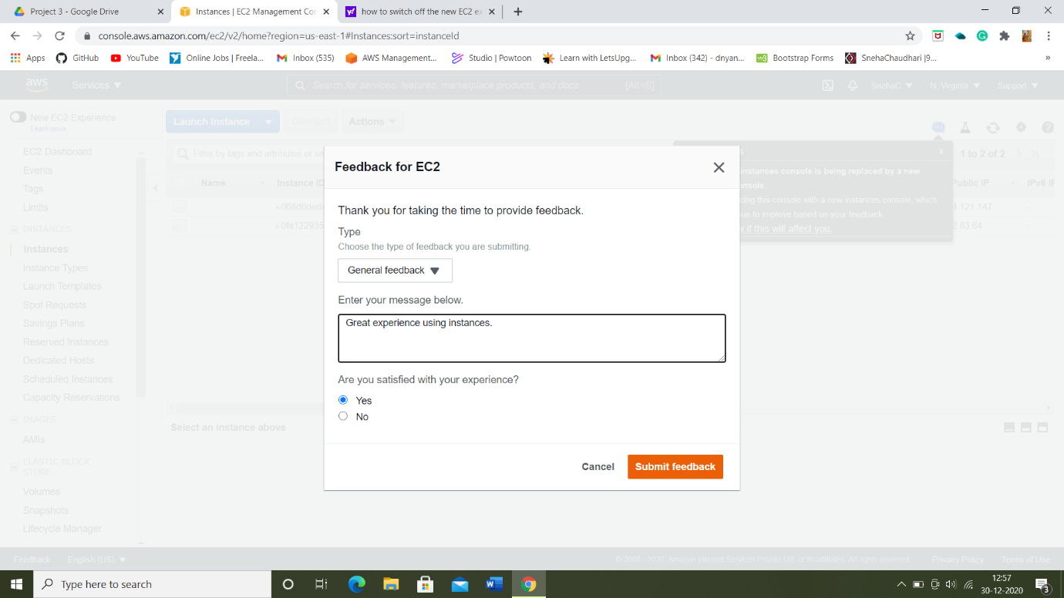

* Here, we can see the instance-id created is same as shown in the log-output page. Therefore, the EC2 instance that has been provisioned by lambda function:

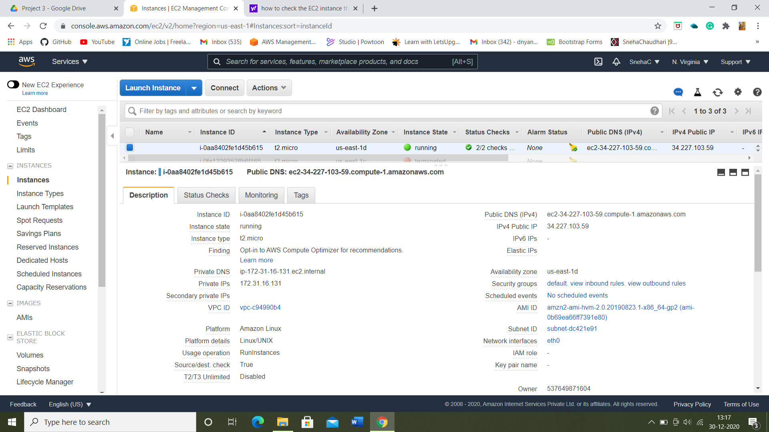

**THE END**